1. Inequality and Wealth

**Figure 4: The actual United States wealth distribution plotted against the estimated and ideal distributions.**

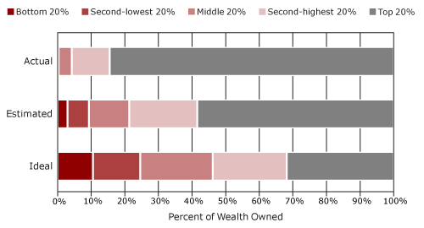

A. Wealth

1. Net worth: what you own minus what you owe

2. Financial wealth: easily converted to cash or income producing

(stocks, bonds, trusts, business equity, financial securities, commercial property)

B. Net Worth by household (% of total wealth and average)

1. Top 1% = 35.4%/$16, 439,400

2. Top 20% = 89% /$2,061,600

3 Bottom 80% =11% of wealth

a. Middle 20%= $61,000

b. Bottom 40%= -$10,600

4. Top .01=Walton Family (6) have more wealth than 40% of American Families combined ($102.7 billion)

C. Financial wealth

1. Top 1% = 42%

2. Top 20% = 95%

(Stocks, bonds, trusts, business equity, financial securities)

3. Bottom 80%=5%

D. Trend (top 1%)

1. Since 1970s: +2x

2. 2001 to 2008 ($186 billion to $816 billion)

3. (rest of us) 2007 to 2010 -30% ($77, 300 median)

E. Comparison

1. Industrial countries

2. Historically

<http://www.youtube.com/watch?v=slTF_XXoKAQ>

F. Median Net Worth/Financial Wealth Households: Race

1. White $97,000/.$27,000 (between 2005-09 -16%)

2. African American $4,900/0.1 (between 2005-09 -53%)

1. Hispanic $1,300/0 (between 2005-09 -66%)

II. Inequality by Income

A. Income

1. Investment income (from financial wealth)

2. Income from work

3. Real income

a. income adjusted for inflation

b. example: median income for men avg: 1973 $33,000 2005 $29,000

B. Income by % and/or avg

1. top .01%: $27, 342, 212 (15,000 households, + bottom 150 million)

2. top 1% : 23% /$1,137,684

3. top 20%: 60% of income

4. median household:. $52,000( -$6,000 from 2010 to 2012)

5. bottom 40% avg $17,300

C. Source of income

1. top 10% receive 80% of investment income

2. bonuses: financial industry (38 companies= $146 billion)

D. Trend

1. Gini index .466 ^

2. top 1%

a. last 30 years 2x share of income (CBO)

b. During “economic recovery” 2009-2010 top 1% 93% of all income growth

c. CEOs: 1980 40x/present 300x

-Top 400: 2001 to 2008 (2x to $263 million- 63% capital gains, tax rate 16.6%, no social security)

3. Comparison

a. world: 93rd between Mexico and Iran.

b. historically

C. Median Household Income: Race

1. White $50,784

2. Black $30, 858

3. Hispanic $35,967

4. Trend

a. Same

b. New trend: class within race

D. Inequality by gender: income

1. $41, 386 m : $31,858 w

1. w -1.8%

E. Profit: Corporate Citizens

1. 2001 $503 billion 2008 $1.35 trillion

2. ALL TIME RECORD 2010 $1.68 TRILLION

1. Cash on hand $2 trillion (largest in over fifty years)
2. Fortune 500 2011 all time record $824 billion
3. “Overseas”

<http://www.youtube.com/watch?v=Pin8fbdGV9Y&list=PLB3A3B6087444D958>

<http://www.youtube.com/watch?v=8SuUzmqBewg&list=PLB3A3B6087444D958>